**Course: Advance Bio Informatics**

**Module Title: Components of Semantic Web (continue)**

**Module No: 69**

**Ontology**

It is an explicit description of a domain.

1**. Taxonomies:**

An organized set of terms. A classification and a tree Hierarchal, tree-like structures similar to organizational charts

2**. Sets** of inference rules Used to organize semantics

**Ontology Components**

* *Concepts*
* *Properties* and attributes of concepts Constraints on properties and attributes
* *Individuals* (often, but not always)

Ontology defines a common vocabulary a shared understanding.

**Example**

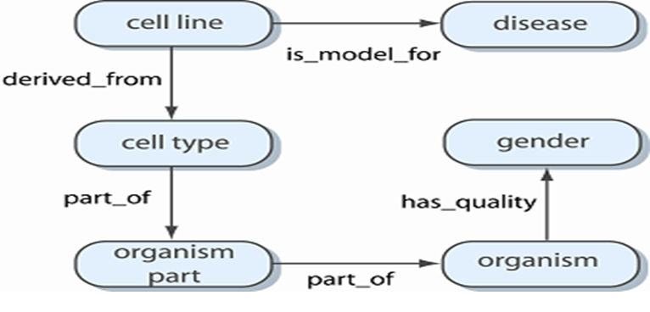**Individuals**

Smallest elements that constitute a world. No sub-individuals. Have an identity and can be counted. Hardly use while building ontologies. Focus on general Knowledge.

**Classes**

A class is a set of individuals (its instances. We do not have to know explicitly all the individuals who instantiate a class. Usually, ontologies do not have instances because they focus on general knowledge

* Classes are used in intension (e.g. Student is a person who attends a school or an university, asserts a proposition about all the past, current, future students in this world or in a parallel one)
* An individual can instantiate several classes

**Properties**

Relationship for describing individuals

**Object property:** is a relationship from instances of some class to instances of some (other) class

**Data type property:** is a relation from instances of some class to a data type such as string, integer, float, date,...

**Annotation** **property**: can be any relation applied to individuals, classes or properties. Useful for humans. Ignored by reasoners